PC BASED MANUAL GUIDED VEHICLE USING RF WIRELESS TECHNOLOGY

The main aim of this project is to design a system that behaves like a robot and control it using RF technology. Robot is a system that contains sensors, control systems, manipulators, power supplies and software all working together to perform a task. Designing, building, programming and testing a robot is a combination of physics, mechanical engineering, electrical engineering, structural engineering, mathematics and computing.

This project describes a new economical solution of robot control systems. The presented robot control system can be used for different sophisticated robot applications. The control system consists of an RF transmitter and receiver, a microcontroller that collects data from the RF receiver and controls the robot.

The RF modules used here are STT-433 MHz Transmitter, STR-433 MHz Receiver, H12E RF Encoder and HT12D RF Decoder. The controlling of the robot is done by providing the input from the PC at the transmitter. The microcontroller, at the transmitter side, accepts the input from the keyboard and passes this data to the RF transmitter.

At the receiving end, the RF receiver receives this data, gives it to RF decoder. This decoder converts the single bit data into 4-bit parallel data and presents it to the microcontroller. Now, the controller read the data and performs the corresponding action according to the given input at the transmitter side i.e., to move the robot back, front, left or right.

SOFTWARE AND HARDWARE TOOLS:
Software Tools:
- Keil compiler
- Orcad.
- Proload

Hardware Tools:
- Microcontroller AT89S52.
- RF transmitter and receiver modules.
- RF encoder and decoder.
- DC motors and L293D for Robot.
- PC
- MAX232

Block diagram
Transmitter section
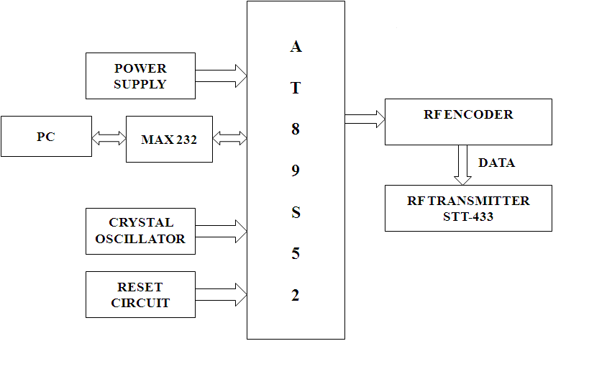

Receiver section
